Horse Weight Building Supplements Comparison Chart
Drs. Foster & Smith Educational Staff
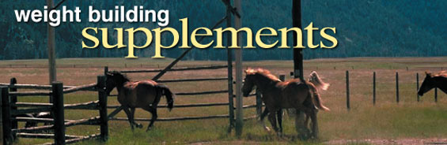
Many factors influence your horse's weight. Caloric intake, health status, activity level, metabolism, digestive efficiency, temperament, food quality, genetics, and more can all contribute to how much weight your horse gains or loses. But there is no magic formula to determine which component most affects your horse's - or his barn mate's - particular weight.
Thankfully, nutritional supplements are available to help your horse maintain his ideal weight, whether he's hardworking, a performance horse, or a hard keeper. Before starting any weight gain supplement regimen, however, consult your veterinarian. Significant weight loss can signify a serious medical condition.
Product | Cool Calories 100  by Start to Finish | Focus WT  by Source | Hard Keeper  by VitaFlex | Muscle-UP  by AniMed | Platform Weight  by Farnam | Weight Builder  by Farnam
Form | Powder | Powder | Granules | Powder | Fine Pellets | Powder
Daily Serving | 2 to 4 oz | 1-1/2 oz | 4 oz | Approximately 1/2 oz | 2 oz | 4 oz
Container Size/  # Servings* | 8 lbs:  up to 64 | 3-1/2 lbs:  up to 37 | 6 lbs:  up to 24  -  12 lbs:  up to 48  -  24 lbs:  up to 96 | 2-1/2 lbs:  up to 80 | 3-3/4 lbs:  up to 30 | 8 lbs:  up to 32  -  28 lbs:  up to 112
Base | Vegetable Oil | Alfalfa,  Seaweed | Vegetable Oil,  Animal Fat,  Flaxseed | Gamma Oryzanol | Vegetable Oil | Grains,  Flax Meal,  Vegetable Fat
Fat (mg/oz) | 28,066 | 851 | 11,340 | 0 | 28,066 | 11,340
Protein (mg/oz) | 0 | 3,402 | 4,253 | 0 | 0 | 3,969
Probiotics | No | Yes | Yes | No | No | No
Additional Ingredients |  | Vitamins,  Chelated Minerals | Omega 3,  Omega 6 Fatty Acids | Creatine,  Vitamin E,  DMG | Omega 6 Fatty Acids | Omega 3 Fatty Acids
Gamma Oryzanol  (mg/oz) | No | No | No | 1,000 | No | No
* Number of servings is based on daily maintenance dosage for a 1,000 lb horse.
The Ingredients of Weight Gain Supplements
Weight building supplements traditionally contain protein and calorie sources, and may contain certain probiotics for better digestive health, to help your horse gain weight. Some promote muscle development. Combined with a suitable, nutritious diet, and good healthcare, including a comprehensive deworming program, weight gain supplements may benefit your horse. The components of most equine weight gaining feed additives include:
- Protein is found in every organ and tissue of the body. It is vital for muscle development during growth and exercise. Amino acids are the main building blocks of protein.
- Fats help increase a feed's energy density, which is the number of calories contained in 100 grams of a particular food. Vegetable oil is the most commonly used fat source in horse feeds.
- Probiotics are live microorganisms, including bacteria and yeast, which may promote digestive health in your horse. The most common probiotics in horse feeds and supplements include Lactobacillus species (bacteria) and Saccharomyces species (yeast), though some products include additional bacteria species.

